Session Coordinator Information



Thank you for your interest in becoming a volunteer Session Coordinator at Remember My Baby.

This document tells you a little more about the role and how it works, to enable you to decide if it’s right for you.

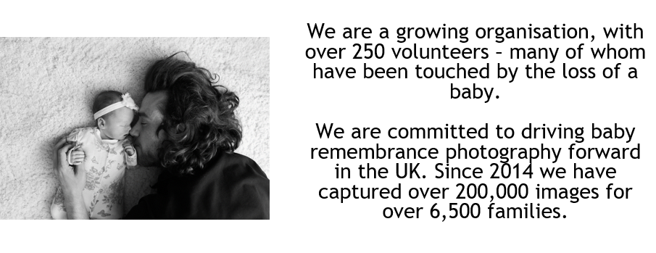

What does a Session Coordinator do?
Session Coordinators (SCs) are the glue that hold RMB’s service together, matching requests for our service from hospitals, hospices and funeral homes with available volunteer photographers in the area.

How does it work?

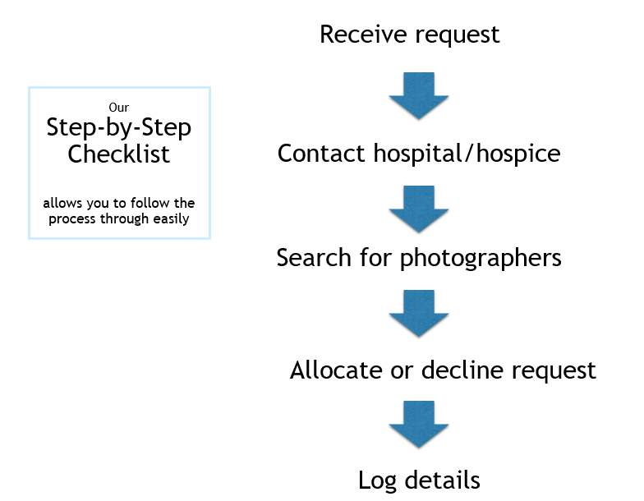

- Hospitals etc. will call our 24/7 freephone line, which is managed by a company called Frontline.
- An email will be sent to the SC distribution list
- The SC on rota will pick up the email and confirm with the hospital that we have the request, and gather any additional information needed
- The SC then contacts all photographers that our system shows as being local to the hospital.
- Once replies are received, the SC decides which one is best placed to carry out the call and advises the hospital and photographers accordingly.
- On some occasions we will be unable to find an available photographer, and the SC will communicate this to the hospital and offer our digital retouching service for any photos taken by the hospital or family.
- Once the call has been dealt with, the session is logged via an electronic form.

What is the time commitment?
SCs work on a rota system as follows:

MONDAY TO FRIDAY
8.00am – 11.00am | 11.00am – 2.00pm |  | 2.00pm – 5.00pm |  | 5.00pm – 8.00pm
WEEKENDS AND BANK HOLIDAYS
9.00pm – 12.00pm |  | 12.00pm – 3.00pm |  | 3.00pm – 6.00pm

We aim to have two SCs on rota for each shift, especially the mornings as they are usually the busiest. There is no minimum requirement for the number of sessions carried out, but we recommend at least 1-2 weekly to keep you in the loop. We always struggle to fill weekend sessions, so the ability to cover these is a real bonus.

During a rota slot, you only need to be in a position to check for incoming requests and act upon them shortly after they arrive. There is, of course, no knowing how many sessions will come through in any shift – some may get none at all, whilst some others can have several. Many of our SCs do other things at the same time as their shift, just keeping an eye out on their emails and springing into action when one comes through.

What equipment do I need?
Our SCs all work from their home or work environment. You will need access a mobile phone and a computer as you will be accessing the internet. We have a WhatsApp group for general communication, and also some closed Facebook groups for volunteers where posts will need to be made.

What support will I get?
We have a lively WhatsApp group for SCs and also a Facebook group, and there is a group for Photographers that the SCs are part of. We also have regular online catch-up meetings for the SC team – the team is based across the UK so it’s a great opportunity to get together for a chat with colleagues and to put faces to names.

Our Volunteer Services Coordinator is also on hand to deal with any queries that you may have and for a chat if you need it. We do also have access to a counsellor if required.

I have lived experience of baby loss. Is this role right for me?
Only you can answer that question as every bereaved parent’s journey is different. It’s a great way to give back to something that directly helps other bereaved parents in their darkest hours, but you should think carefully about your own journey and the potential for grief triggers.

As part of the role, we need to obtain detailed information about the condition of a baby in order to make a decision on which photographer to send. We wouldn’t want to send an inexperienced photographer in to a particularly difficult photoshoot.
Some of our photographers also share the images that they have taken (with the appropriate permission from parents of course!) in the Facebook group, and so you will see those too.

I want to join. What happens next?
Please confirm that you are happy to join us by emailing info@remembermybaby.org.uk

We will then book you onto a New Session Coordinators training session, which goes over the process in more detail and introduces you to the step-by-step Checklist. We’ll then book you onto our systems and arrange for you to shadow an experienced coordinator for your first couple of sessions.

We will also need to seek two references from employers or people that you know well. We handle data coming from the NHS, and so for safeguarding purposes need to establish that you are suitable for the role.

Thanks for your interest and we hope to welcome you to Team RMB!

